CS 32 Homework 5, by Tomas Kaljevic

* 1. 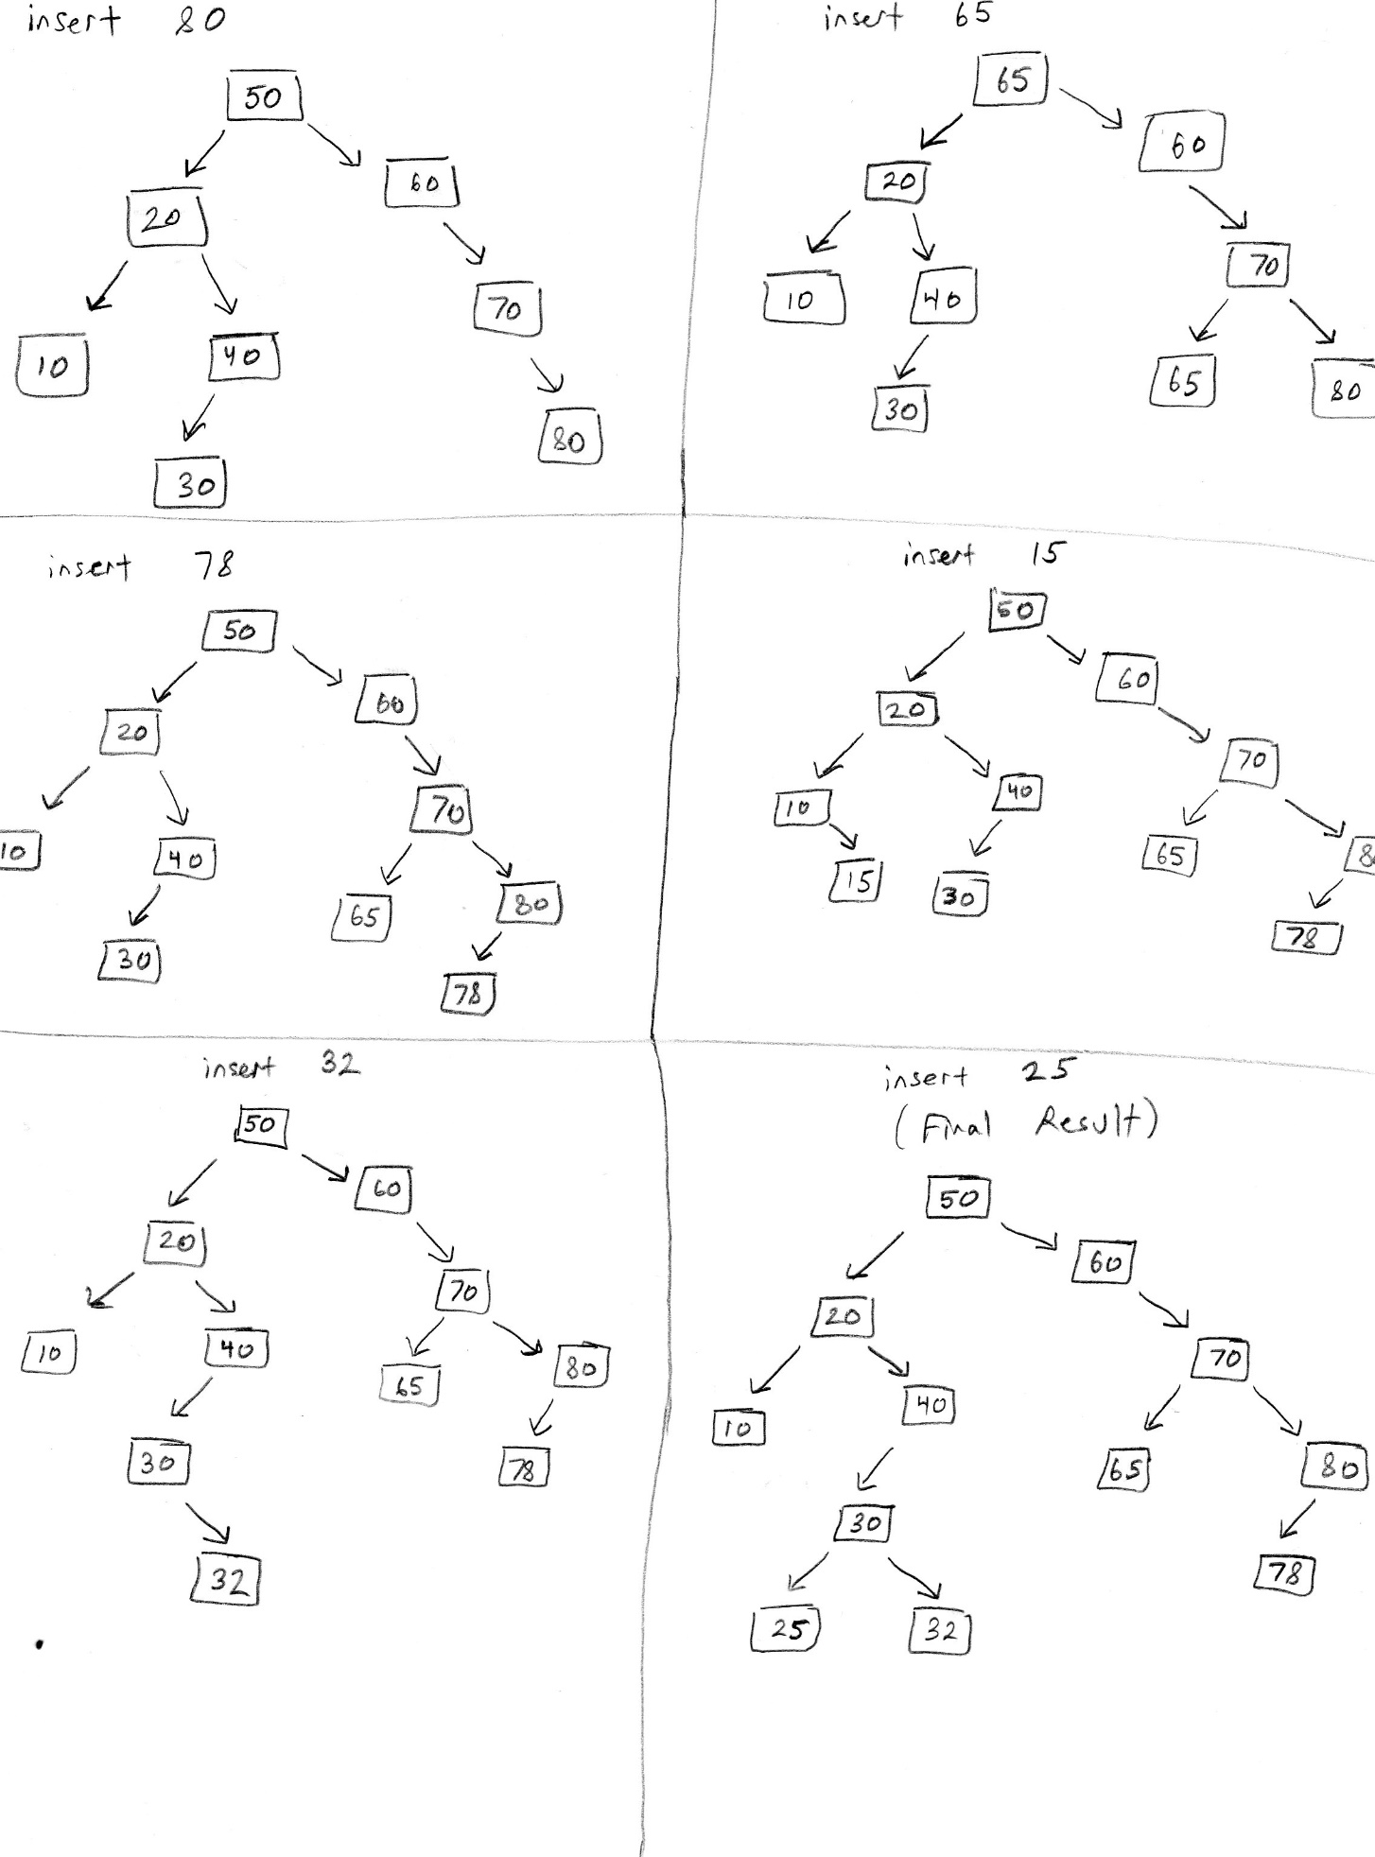
  2. Inorder: 10 20 25 30 32 40 50 60 65 70 78 80

Preorder: 50 20 10 40 30 25 32 60 70 65 80 78

Postorder: 10 25 32 30 40 20 65 78 80 70 60 50

* 1. 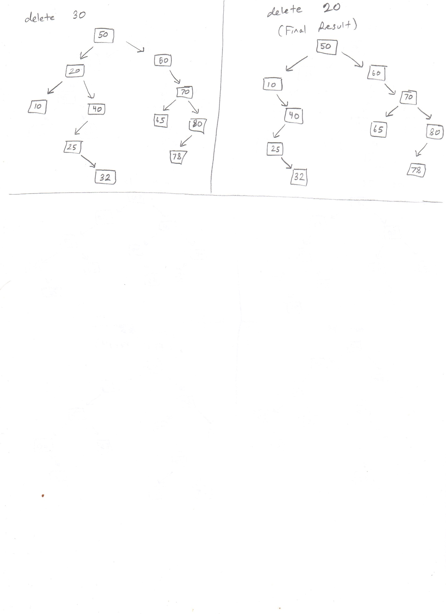



* 1. void insert(int value) {

allocate a new node “node” with the value parameter whose left, right, & parent are nullptr

if the root node is a nullptr

set root to be equal to node

otherwise

let BinaryTreeNode\* p = the root

let BinaryTreeNode\* q = the root

while q is not nullptr {

p = q

if the value parameter is less than p’s value

q = p’s left child

otherwise

q = p’s right child

}

if the value parameter is less than p’s value

set p’s left child to be node

otherwise

set p’s right child to be node

}

* 1. 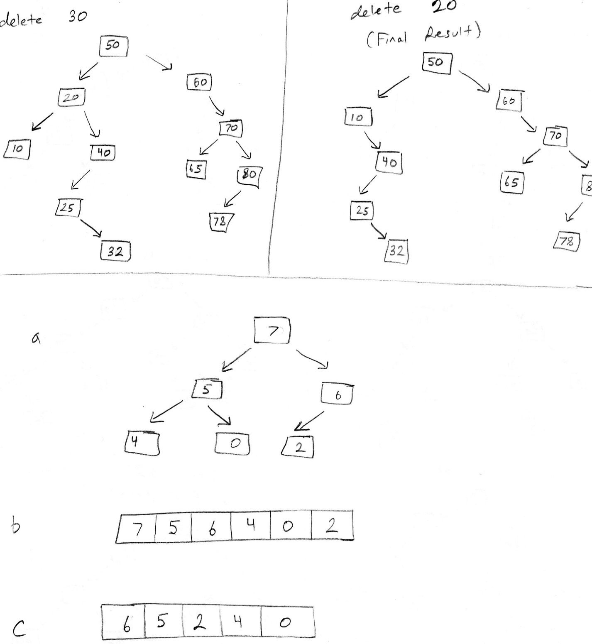

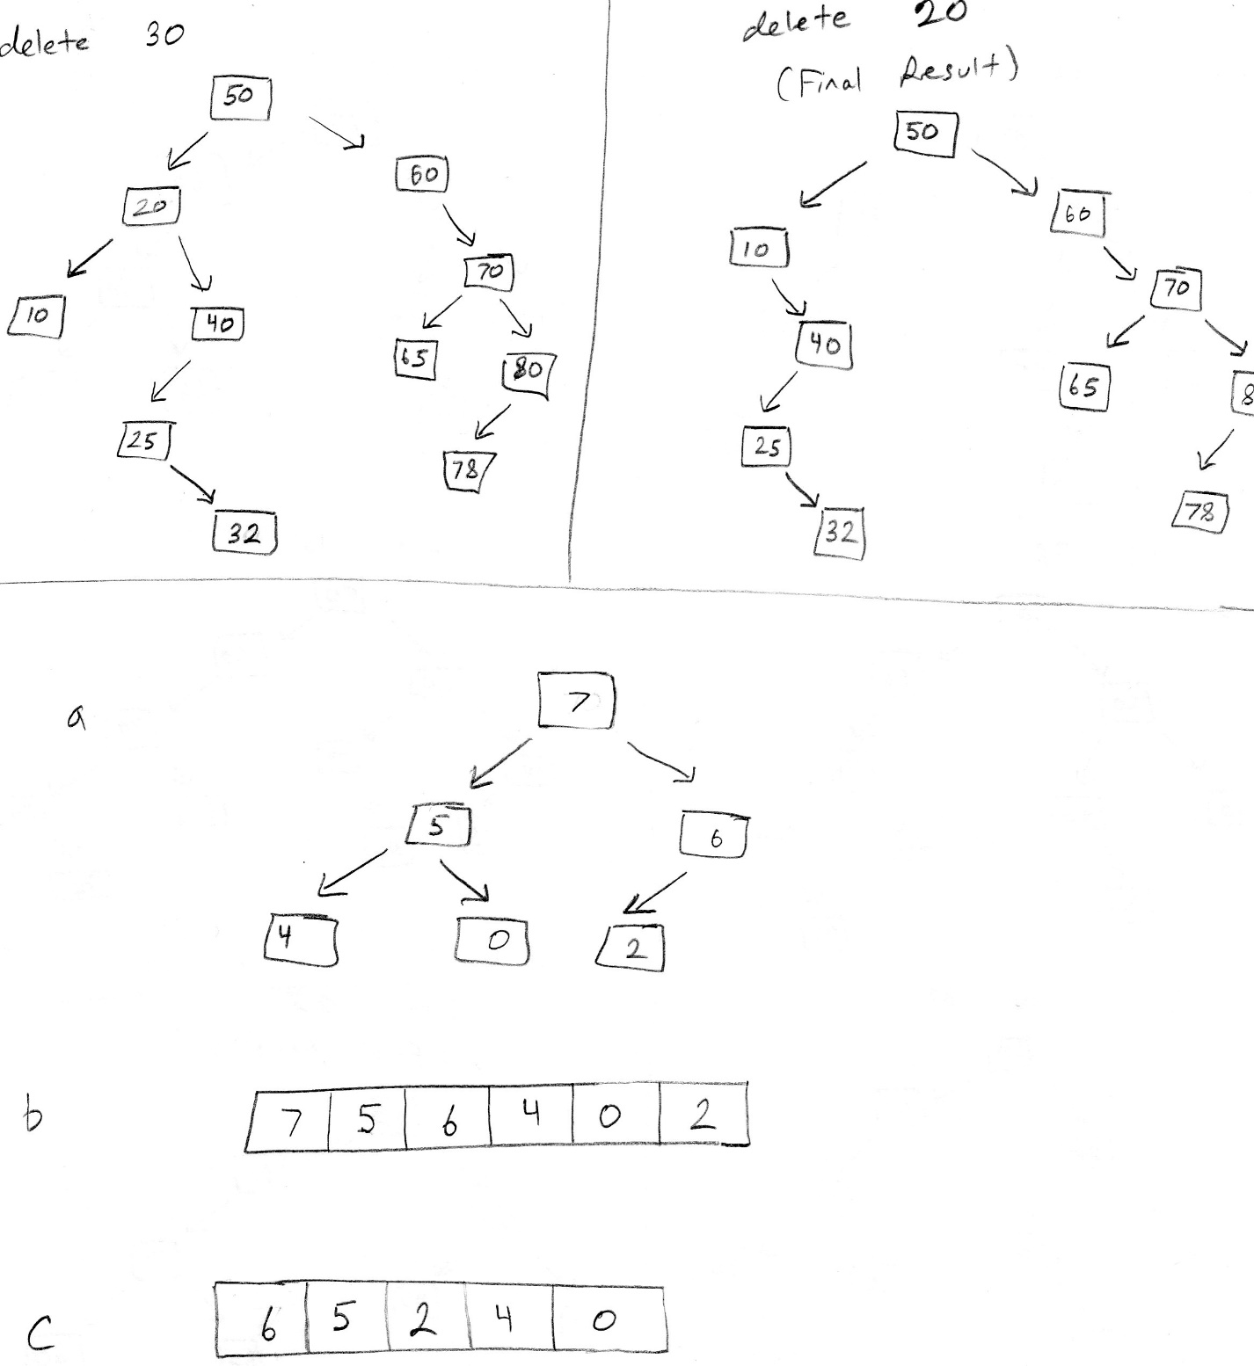



* 1. O(C+S)
  2. O(logC + S)
  3. O(logC + logS)
  4. O(1 + logS) 🡪 O(logS)
  5. O(1 + 1) 🡪 O(1)
  6. O(logC + S)
  7. O(SlogS)
  8. O(ClogS)